What is Linux Operating System
The Linux Operating System is a type of operating system that is similar to Unix, and it is built upon the Linux Kernel.
The Linux Kernel is like the brain of the operating system because it manages how the computer interacts with its hardware and resources. It makes sure everything works smoothly and efficiently. But the Linux Kernel alone is not enough to make a complete operating system.
To create a full and functional system, the Linux Kernel is combined with a collection of software packages and utilities, which are together called Linux distributions.
These distributions make the Linux Operating System ready for users to run their applications and perform tasks on their computers securely and effectively. Linux distributions come in different flavors, each tailored to suit the specific needs and preferences of users.

Linux History

Linus Torvalds designed the free and open-source Linux operating system kernel in 1991, inspired by the UNIX operating system and the MINIX operating system. His goal was to build a flexible and affordable platform for personal computing. The initial release of the Linux kernel quickly drew global attention from developers and enthusiasts, encouraging collaborative development. Over time, this led to the creation of complete Linux distributions, powered by the kernel and supported by open-source software packages.
Over the years, Linux has become known as a key component of modern computing, powering everything from servers and personal computers to supercomputers and smartphones. Due to its flexibility, durability, and strong community support, developers, businesses, and educational institutions frequently opt for it.

What is Linux?
Linux is based on the UNIX operating system.
UNIX is a powerful, multi-user, multitasking operating system originally developed in the 1970s at AT&T Bell Labs. It laid the foundation for many modern operating systems, including Linux.
While UNIX is a licensed operating system (meaning you need to purchase a license to use it), Linux is free and open-source, making it accessible to everyone. Anyone can inspect and modify the source code, which enables global collaboration and innovation. Its efficient performance and strong security model make it suitable for a wide variety of devices and industries.
Since the beginning, Linux has grown into a dependable and safe OS that is used in an array of gadgets, including PCs, cell phones, and huge supercomputers. It is well-known for being cost-effective, which implies that employing it doesn't cost a lot, and efficient, which indicates it can complete a lot of jobs quickly.

What is a “distribution?”
Linux distribution is an operating system that is made up of a collection of software based on Linux kernel or you can say distribution contains the Linux kernel and supporting libraries and software. And you can get Linux-based operating system by downloading one of the Linux distributions and these distributions are available for different types of devices like embedded devices, personal computers, etc.
Around 600 + Linux Distributions are available and some of the popular Linux distributions are:
MX Linux Manjaro
Linux Mint elementary Ubuntu
Debian Solus
Fedora
openSUSE Deepin

Why use Linux?
Because it is free, open-source, and extremely flexible, Linux is widely utilized.
For servers and developers, it is the ideal option because it offers strong security, stability, and performance.
Generally interoperable hardware, a broad software library, and a vibrant community that offers support and regular updates are the many benefits of Linux.
Due to its adaptability, users can customize the operating system according to their own needs, whether they become for personal or large enterprise use.

Architecture of Linux
Linux architecture has the following components:

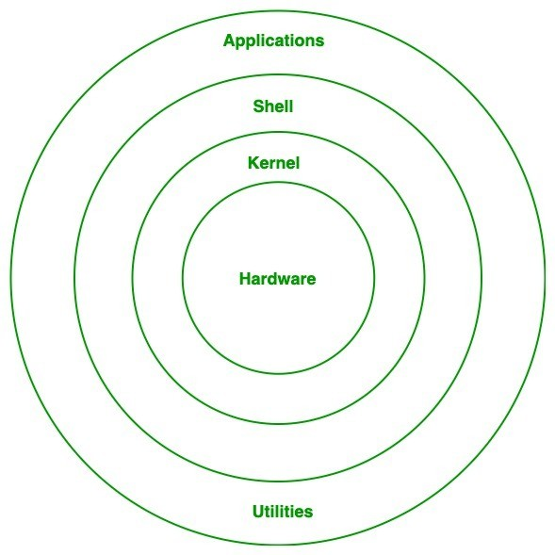

Linux Architecture

- Hardware Layer: The hardware layer encompasses all the physical components of the computer, such as RAM (Random Access Memory), HDD (Hard Disk Drive), CPU (Central Processing Unit), and input/output devices. This layer is responsible for interacting with the Linux Operating System and providing the necessary resources for the system and applications to function properly. The Linux kernel and system libraries enable communication and control over these hardware components, ensuring that they work harmoniously together.
- Kernel: Kernel is the core of the Linux based operating system. It virtualizes the common hardware resources of the computer to provide each process with its virtual resources. This makes the process seem as if it is the sole process running on the machine. The kernel is also responsible for preventing and mitigating conflicts between different processes. Different types of the kernel are:
- Monolithic Kernel
- Hybrid kernels
- Exo kernels
- Micro kernels

The kernel is responsible for:

Memory management: Manages and allocates memory efficiently.
Resource allocation: Distributes system resources to different processes.
Device management: Controls input/output devices like printers and scanners.
Process management: Manages process execution and scheduling.
Application interaction: Bridges applications with system-level functions.
Security: Provides essential system-level security.

- System Library: Linux uses system libraries, also known as shared libraries to implement various functionalities of the operating system., These libraries contain pre-written code that applications can use to perform specific tasks. By using these libraries, developers can save time and effort, as they don't need to write the same code repeatedly. System libraries act as an interface between applications and the kernel, providing a standardized and efficient way for applications to interact with the underlying system.

- Shell: The shell is the user interface of the Linux Operating System. It allows users to interact with the system by entering commands, which the shell interprets and executes. The shell serves as a bridge between the user and the kernel, forwarding the user's requests to the kernel for processing. It provides a convenient way for users to perform various tasks, such as running programs, managing files, and configuring the system.

- System Utility: System utilities are essential tools and programs provided by the Linux Operating System to manage and configure various aspects of the system. These utilities perform tasks such as installing software, configuring network settings, monitoring system performance, managing users and permissions, and much more. System utilities simplify system administration tasks, making it easier for users to maintain their Linux systems efficiently.

How is the Linux Operating System Used?
The Linux operating system is widely used across various domains due to its flexibility, security, and open-source nature:
Servers and Hosting: Powers web servers, cloud infrastructure, and database management systems.
Development: Used by developers for coding, debugging, and running applications.
Desktop and Personal Use: Provides secure and customizable desktop environments.
Cybersecurity: Essential for ethical hacking, penetration testing, and security research.
Embedded Systems: Runs lightweight devices like routers, IoT gadgets, and smart appliances.
Supercomputers: Dominates high-performance computing for scientific research and simulations.
Education: A cost-effective tool for teaching programming and system administration.

Which distribution is right for you?
Choosing the right Linux distribution depends on your needs and experience level:
For Beginners: Because of its simple user interface and strong community support, Ubuntu is a wonderful choice for initially Linux users. On the opposite hand, Linux Mint make it straightforward for novices to transition to Linux by offering an experience comparable to Windows out of the box.
For Advanced Users: Advanced users who appreciate customization and direct control might opt for Arch Linux, it is known for its simplistic style and ability to create highly unique systems from the ground up. Another choice is Gentoo, that provides total control of the system but requires manual setup and a lengthy learning process.
For Developers: Fedora was a popular choice among developers due to its focus upon modern technology and software, making it a perfect platform for software testing and development. On the other hand, Debian is well known for its reliability and extensive package repository, which implies it may be used in both production and development environments.
For Servers: For server environments, CentOS is a powerful, community-maintained distribution that matches Red Hat Enterprise Linux (RHEL) quite somewhat. As an alternative, Ubuntu Server offers an extensive list of server applications in addition to Strong community support and ease of use.

For Lightweight Systems: Lubuntu is frequently picked by users either like lightweight operating systems or have outdated equipment due to its ability to utilize system resources efficiently while maintaining functionality. Another slim option is Puppy Linux, that is made to run well on outdated hardware while maintaining the essential functions and applications.

Installing Linux
- Selecting a Ubuntu, Fedora, or Linux Mint distribution which suits your needs is the initial step in the straightforward procedure for installing Linux.
- Download the ISO file first from the distribution's official website.
- Next, utilize an application like Etcher for macOS and Linux or Rufus for Windows to create a bootable USB drive.
- Following you insert the USB drive into your computer and restart it, you may set the USB drive as the primary boot device by traversing to the BIOS or UEFI settings.
- Upon booting from the USB the hard drive, the Linux setup will show up.
- To partition the drive, choose your time zone, create user accounts, and change system settings, simply adhere to the instructions displayed on the screen.
- When the installation concludes, disconnect the USB drive and turn on your computer normally.

Installing Software on Linux
- On Linux, installing software is simple. For Debian-based systems (like Ubuntu), use package managers like apt and sudo apt install package_name;
- For Fedora, use dnf and sudo dnf install package_name.
- Software centers are another source for a graphical application installation and searching interface.

Advantages of Linux
- The main advantage of Linux is it is an open-source operating system. This means the source code is easily available for everyone and you are allowed to contribute, modify and distribute the code to anyone without any permissions.
- In terms of security, Linux is more secure than any other operating system. It does not mean that Linux is 100 percent secure, it has some malware for it but is less vulnerable than any other operating system. So, it does not require any anti-virus software.
- The software updates in Linux are easy and frequent.
- Various Linux distributions are available so that you can use them according to your requirements or according to your taste.
- Linux is freely available to use on the internet.
- It has large community support.
- It provides high stability. It rarely slows down or freezes and there is no need to reboot it after a short time.
- It maintains the privacy of the user.
- The performance of the Linux system is much higher than other operating systems. It allows a large number of people to work at the same time and it handles them efficiently.
- It is network friendly.
- The flexibility of Linux is high. There is no need to install a complete Linux suite; you are allowed to install only the required components.
- Linux is compatible with a large number of file formats.
- It is fast and easy to install from the web. It can also install it on any hardware even on your old computer system.
- It performs all tasks properly even if it has limited space on the hard disk.

Disadvantages of Linux
It is not very user-friendly. So, it may be confusing for beginners.
It has small peripheral hardware drivers as compared to windows.

Linux Commands
Basic tools for utilizing the command line interface (CLI) to communicate with the operating system are Linux commands. Commonly used commands include ls to list contents of directories, cd to modify directories, and pwd to show the path of the current directory.
With commands like cp (copy), mv (move), and rm (delete), someone can manage file activities. Commands for system information and management include free for memory use, df to evaluate disk space usage, and top for monitoring system processes. Utilizing networking commands such netstat, ifconfig, and ping, users can monitor and troubleshoot network connections.
Package management differs depending on the distribution; Fedora- based machines use dnf, while Debian-based systems use apt.
Commands like cat, grep, awk, and sed are required for editing text files.

